Homework for week 1, submission deadline 23:59 on Sunday night.
1. Complete an Omics-to-Question map: Using your own research project or biological interest. What kind of omics you plan to use to solve the biological research question?
I am a synthetic biology major, and I am interested in stem cell therapy and cellular engineering. In my research on engineered stem cells, if I want to verify whether CRISPR editing introduced off-target mutations or genomic instability, I would use genomics, specifically whole-genome sequencing, to ensure the genetic safety of my cell products before therapeutic application. To assess the differentiation state, purity, and identity of engineered stem cells, I would turn to transcriptomics, particularly single-cell RNA sequencing, because it can reveal lineage-specific gene expression patterns and detect any spontaneous or unwanted differentiation.

- Write one weak prompt and one CARE+V prompt: For the same biological or research question, propose a weak and strong (CARE+V) prompt that can be tested by AI. Use any LLMs to test your prompt and paste the output results below.
Question:How can I design a synthetic gene circuit that enables engineered neural stem cells (NSCs) to sense the inflammatory microenvironment after spinal cord injury (SCI) and controllably secrete neuroprotective factors, while incorporating a biosafety mechanism to prevent tumorigenesis if cells migrate off-target?

Weak prompt：Design a gene circuit for stem cells to treat spinal cord injury.

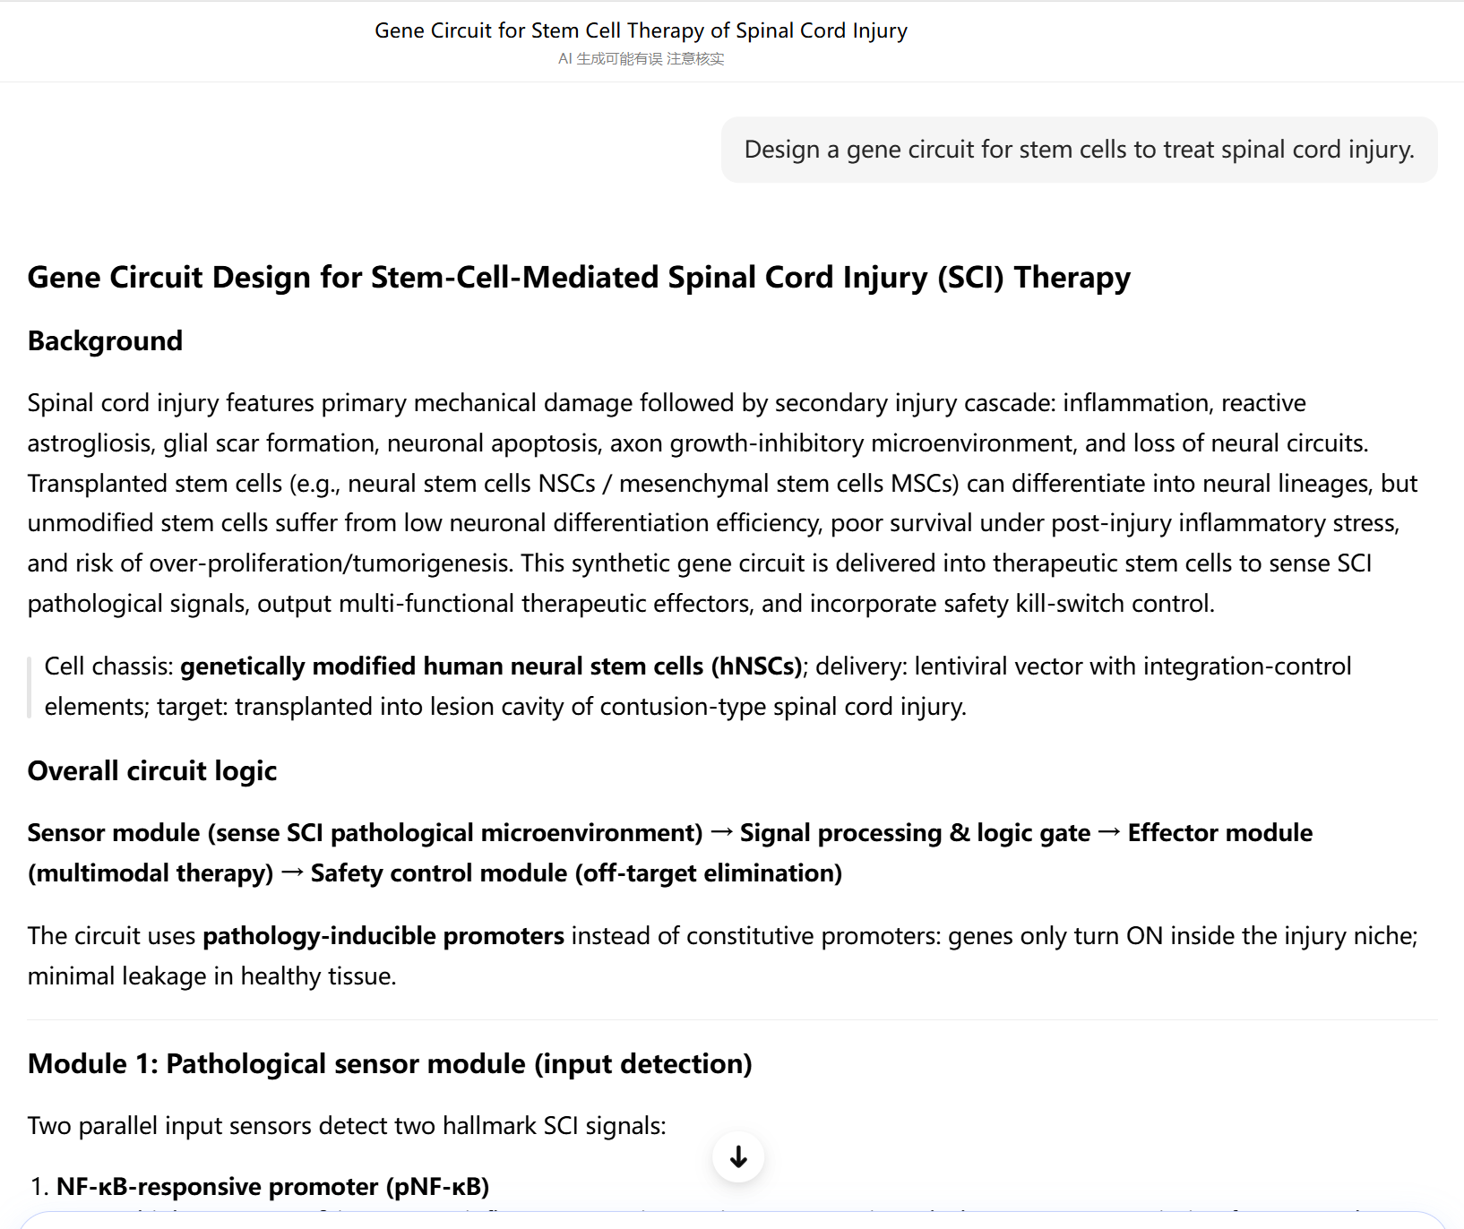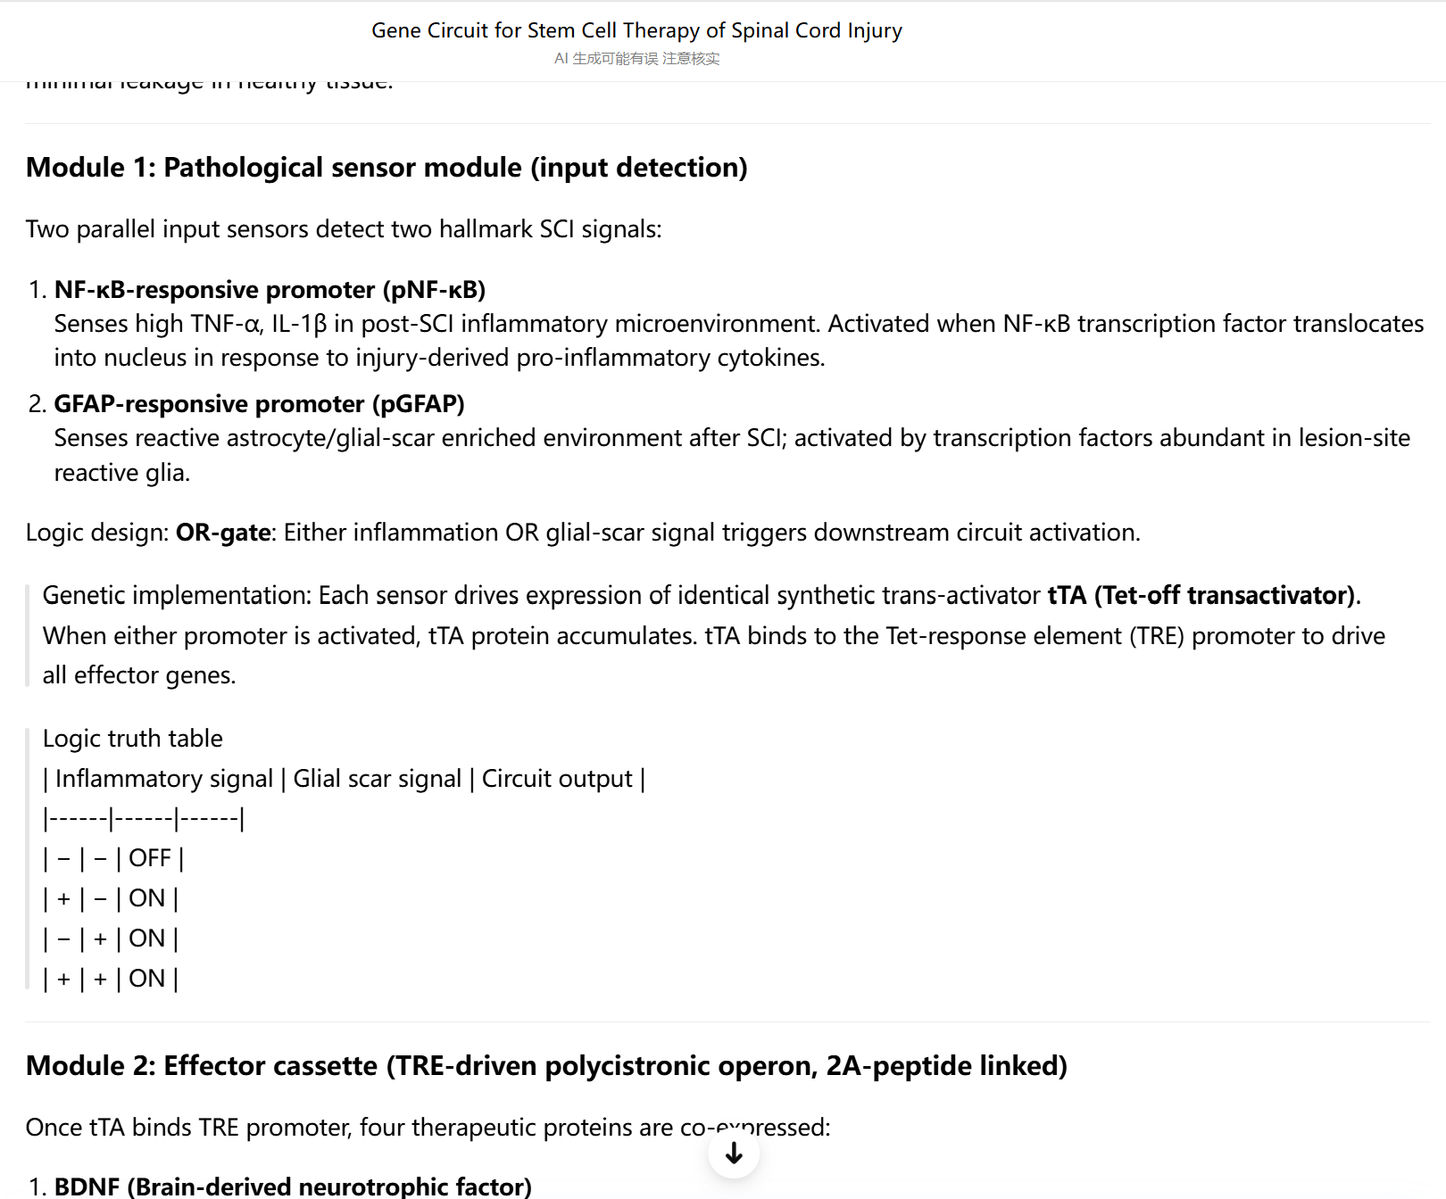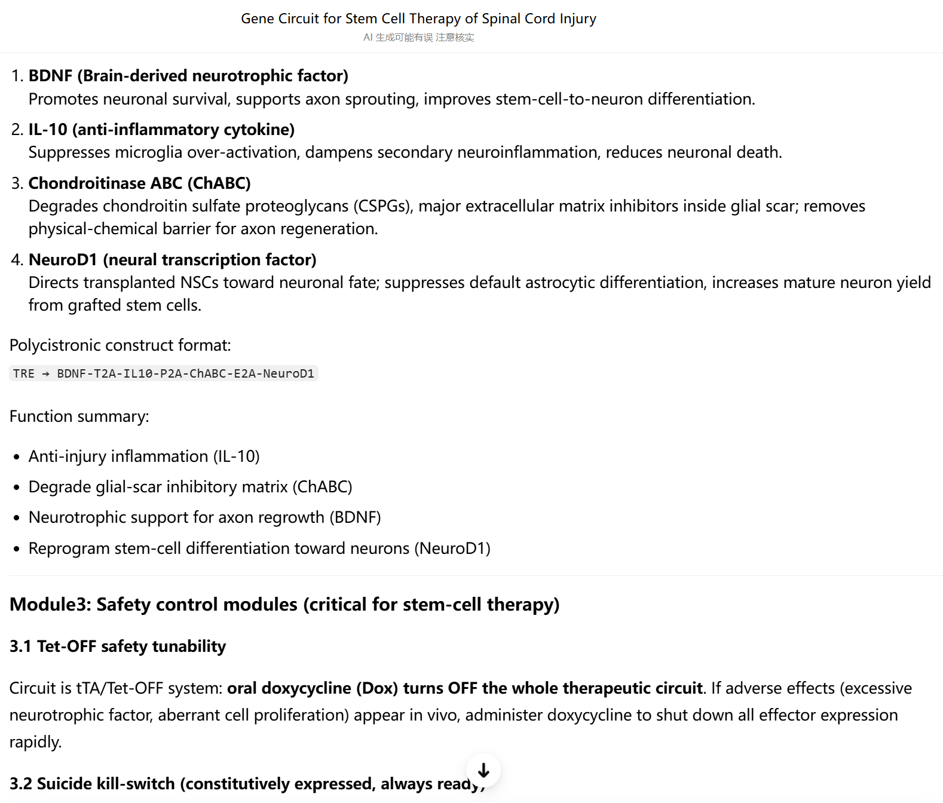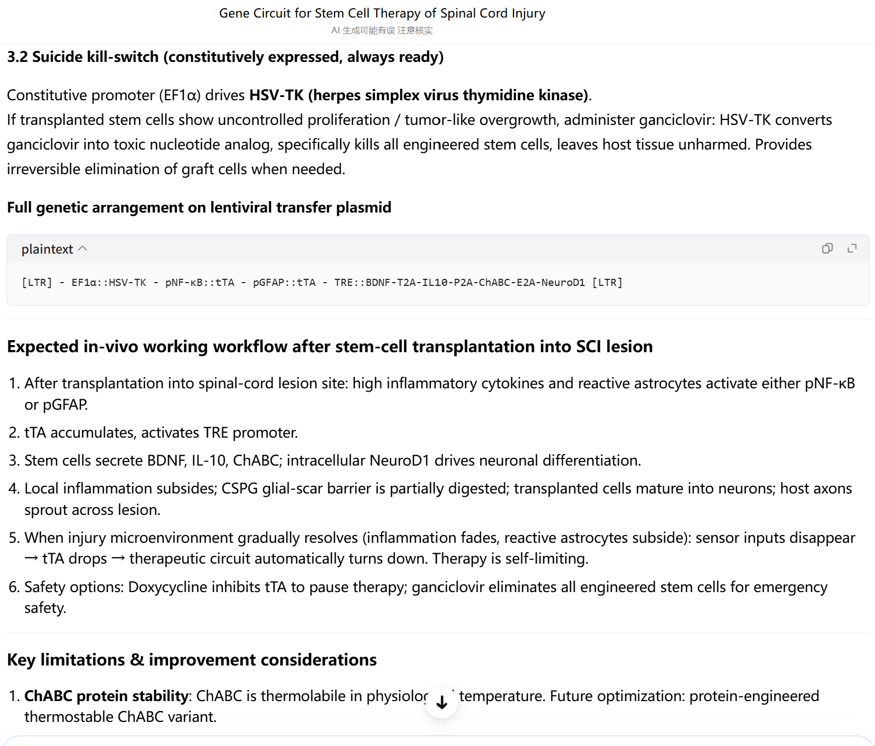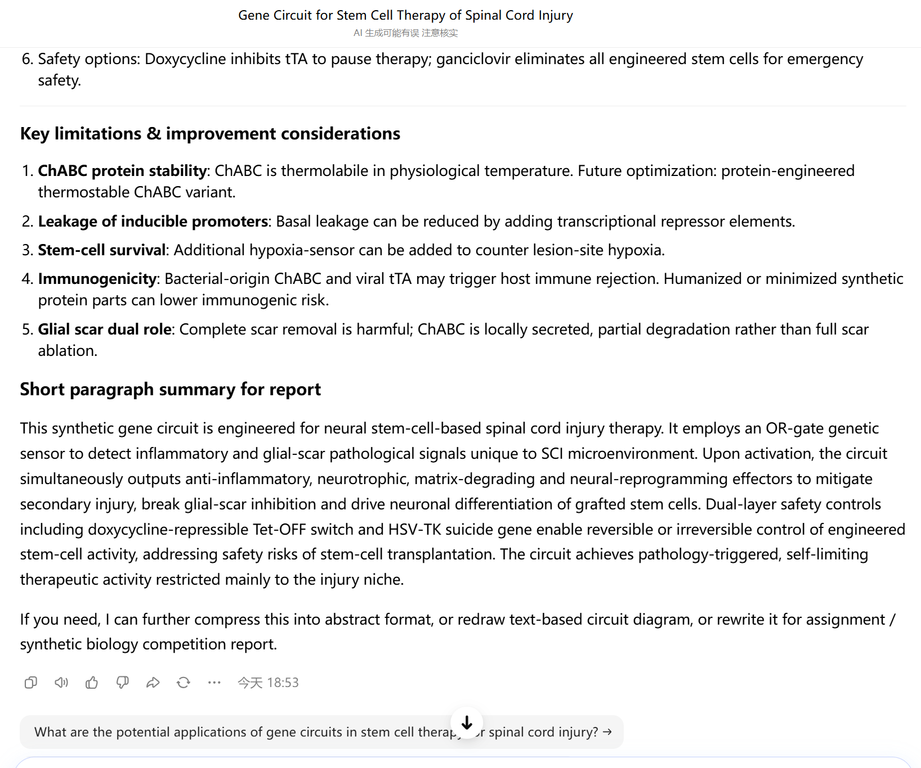
CARE+V prompt: I am a synthetic biology researcher specializing in stem cell engineering. My project focuses on developing engineered neural stem cells (NSCs) for spinal cord injury (SCI) therapy.Design a synthetic gene circuit that enables NSCs to (1) sense pro-inflammatory cytokines at the injury site, (2) respond by secreting neuroprotective factors (BDNF, GDNF, or NGF), and (3) include a built-in biosafety mechanism.
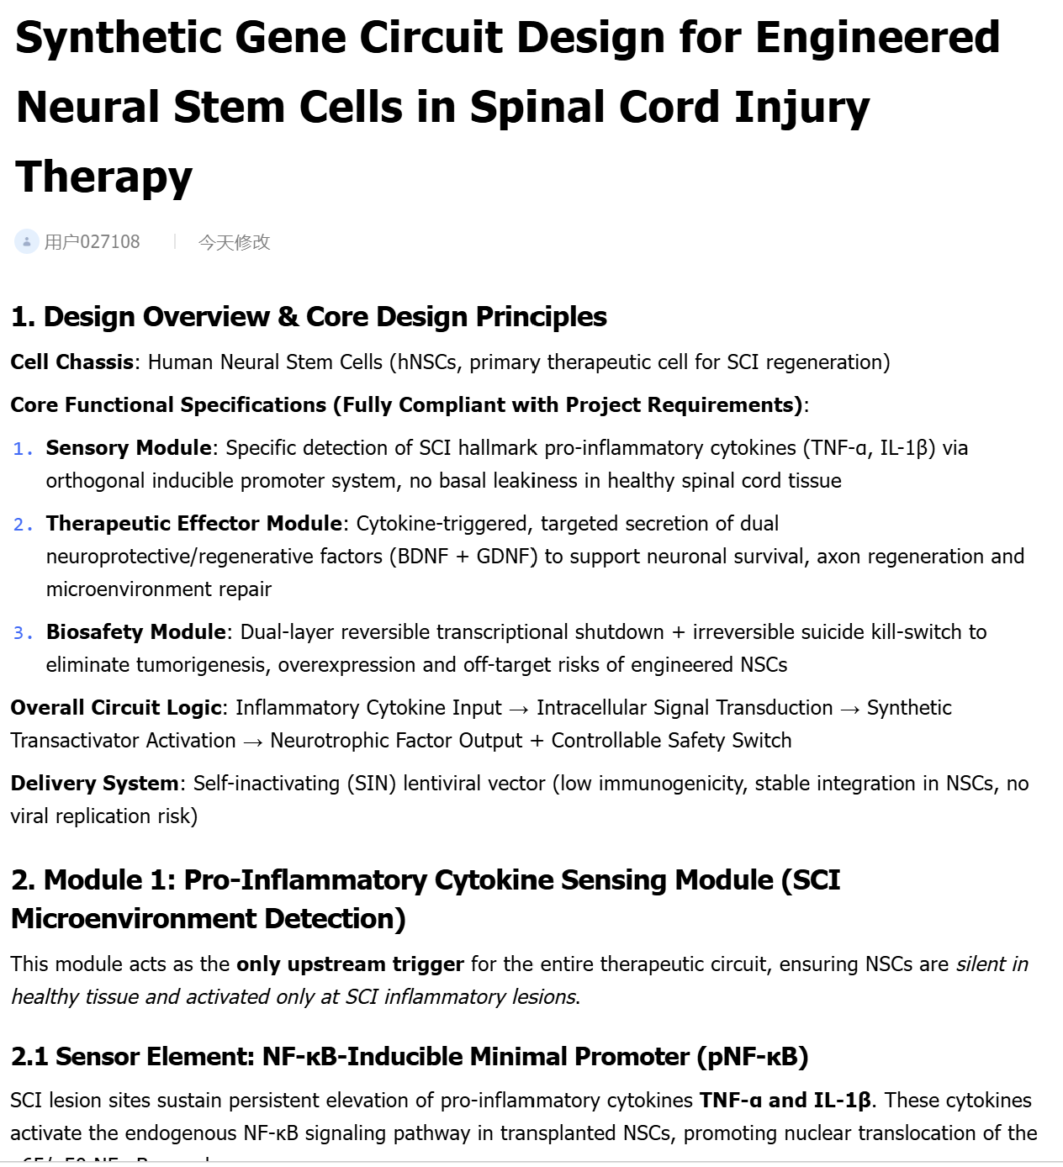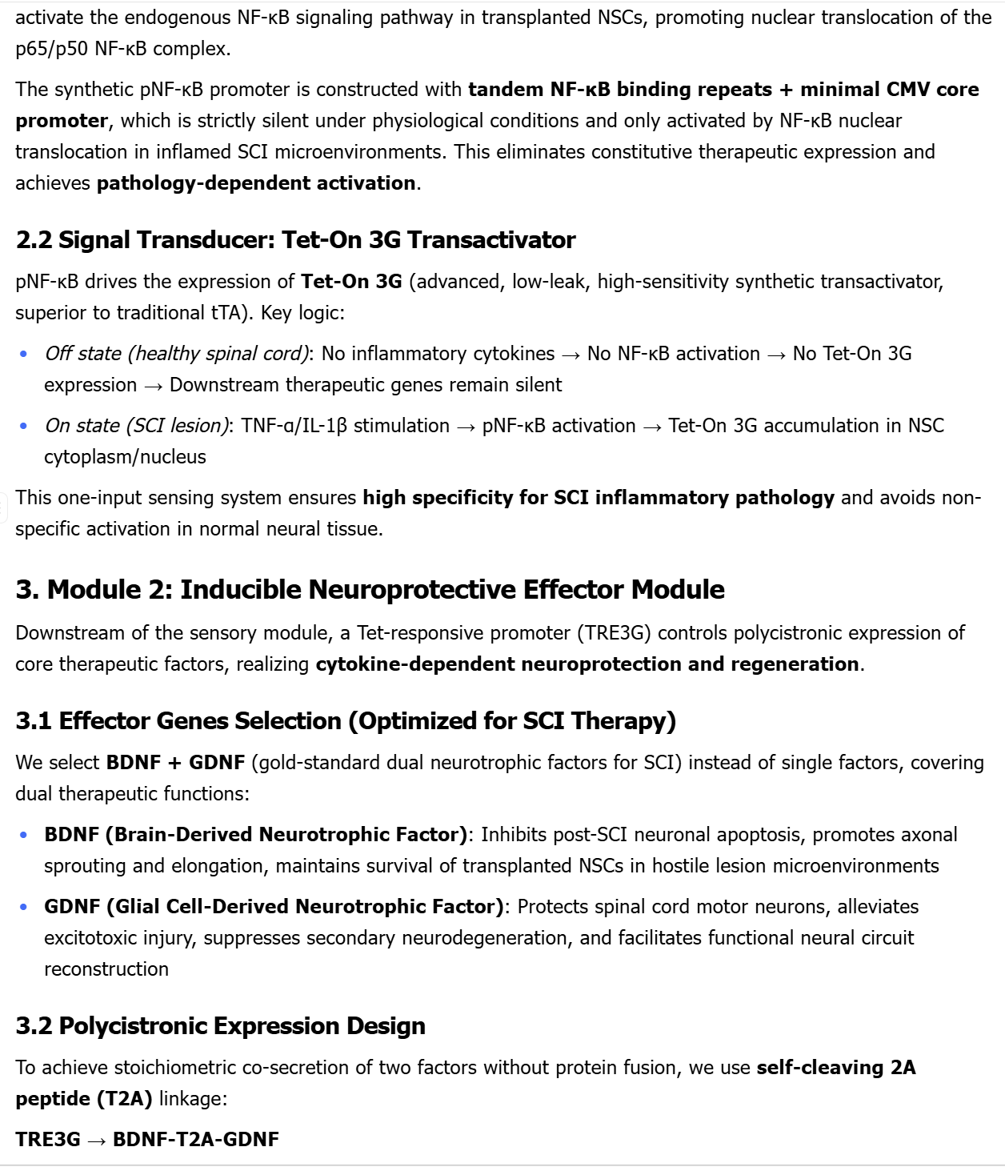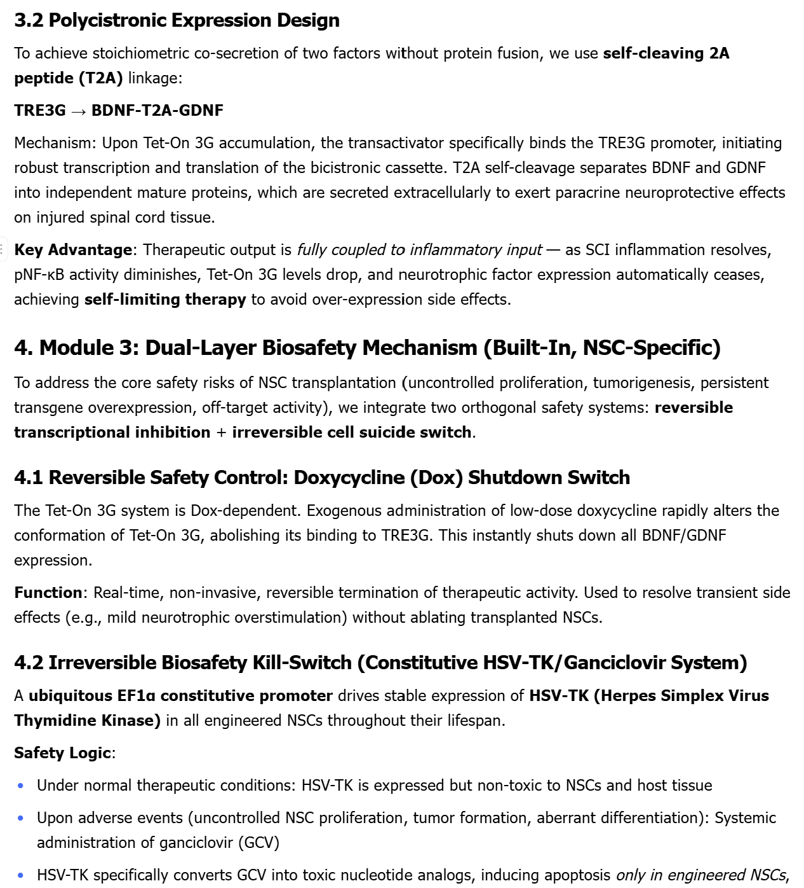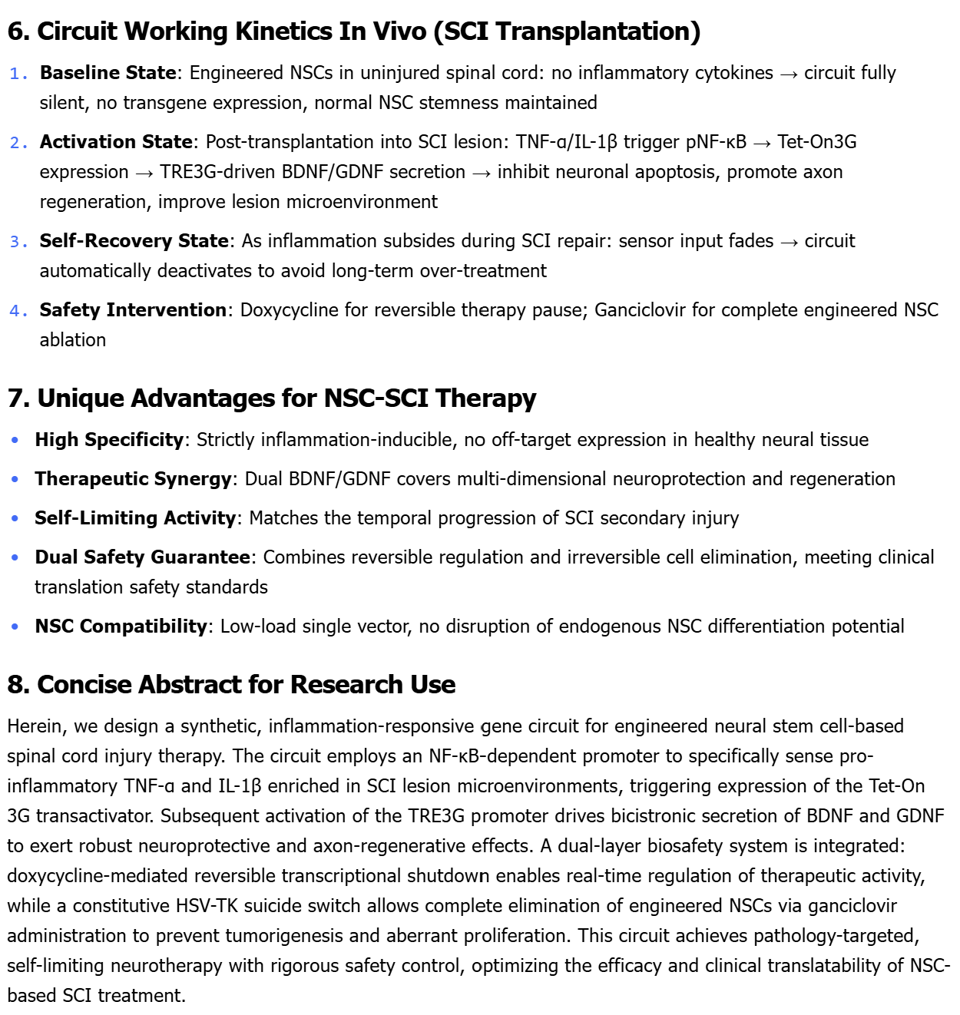

3. Install and Run R and RStudio and save output showing R version and packages.
R: https://cran.r-project.org/ RStudio: https://posit.co/products/open-source/rstudio.
Once installation, please paste a screen cut of Rstudio here. Give a try of R to using the foler (Week1_R_RStudio_Practice_Files) code and data.

A screen cut of Rstudio：
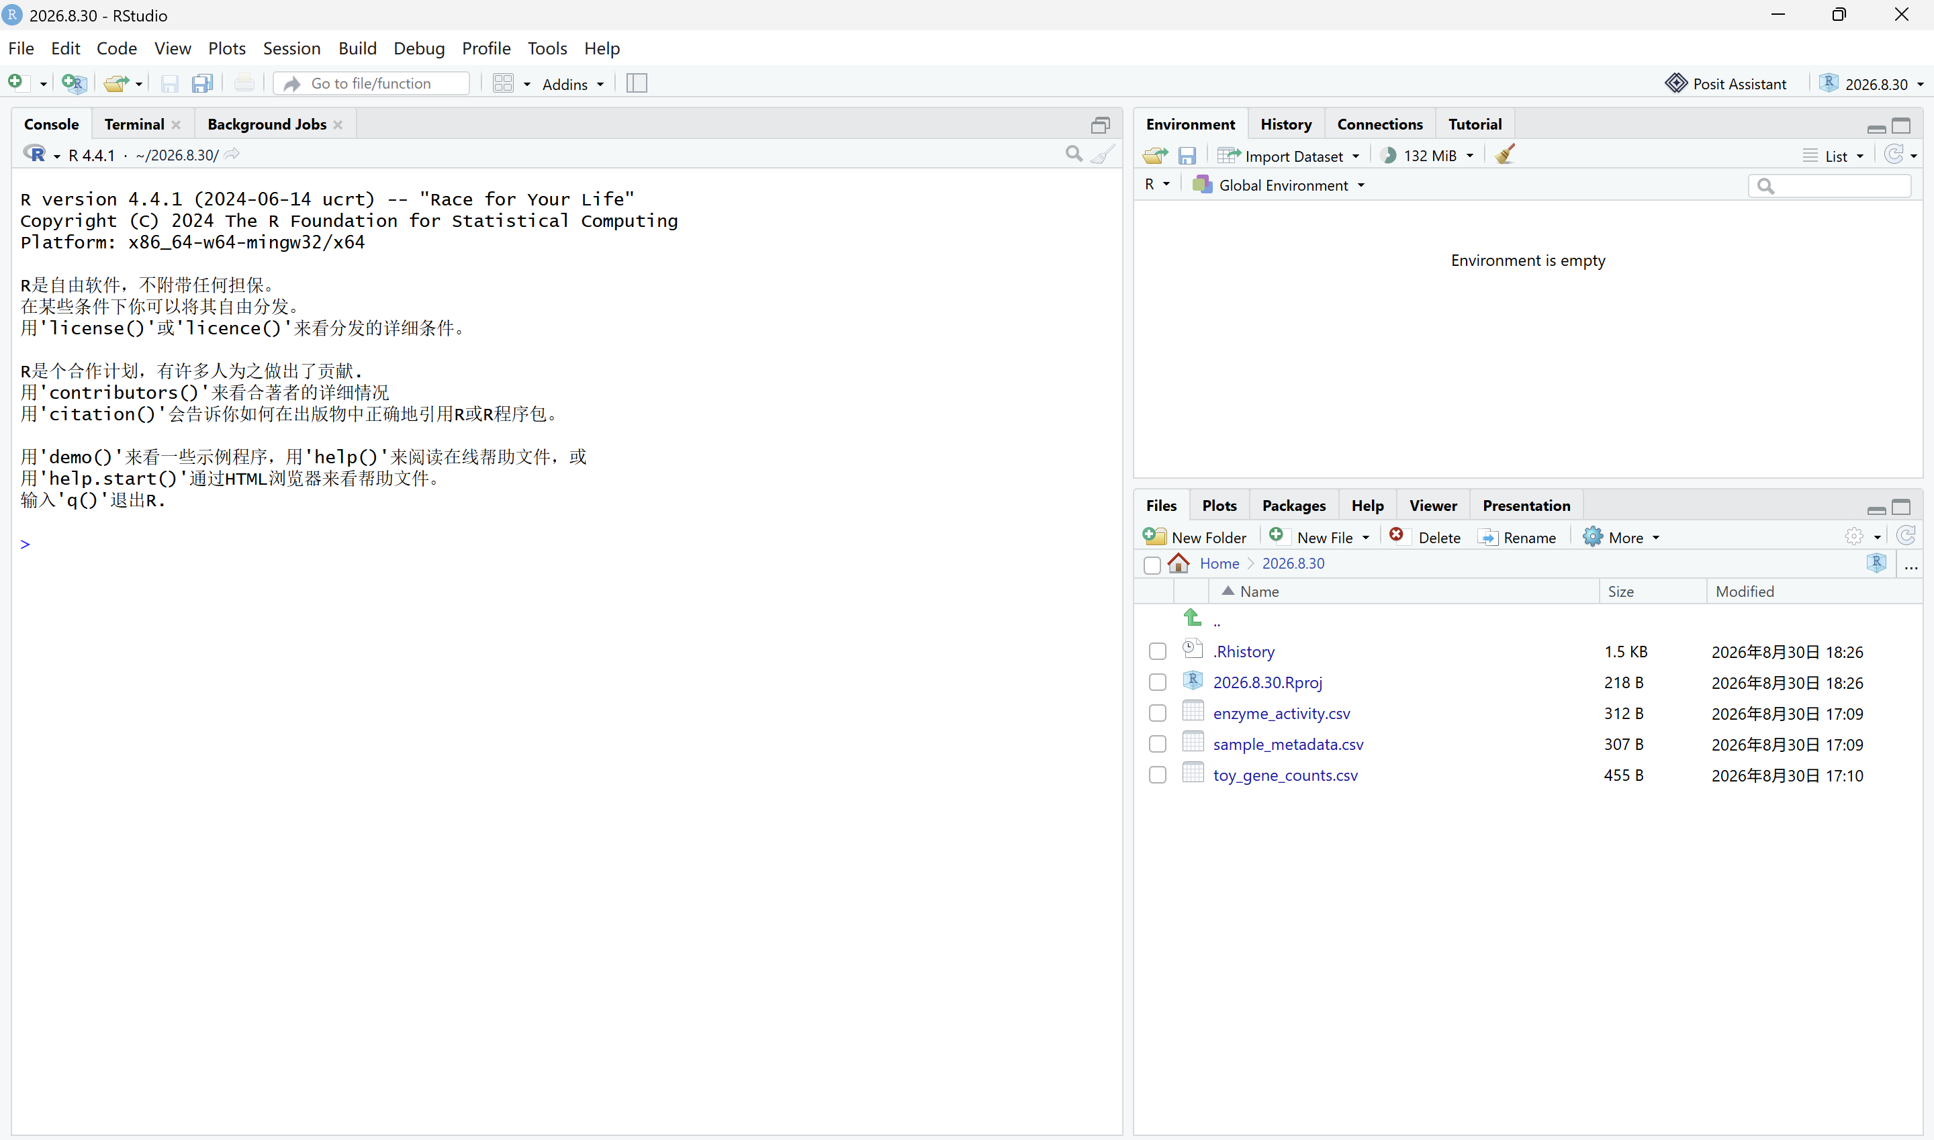
Result:
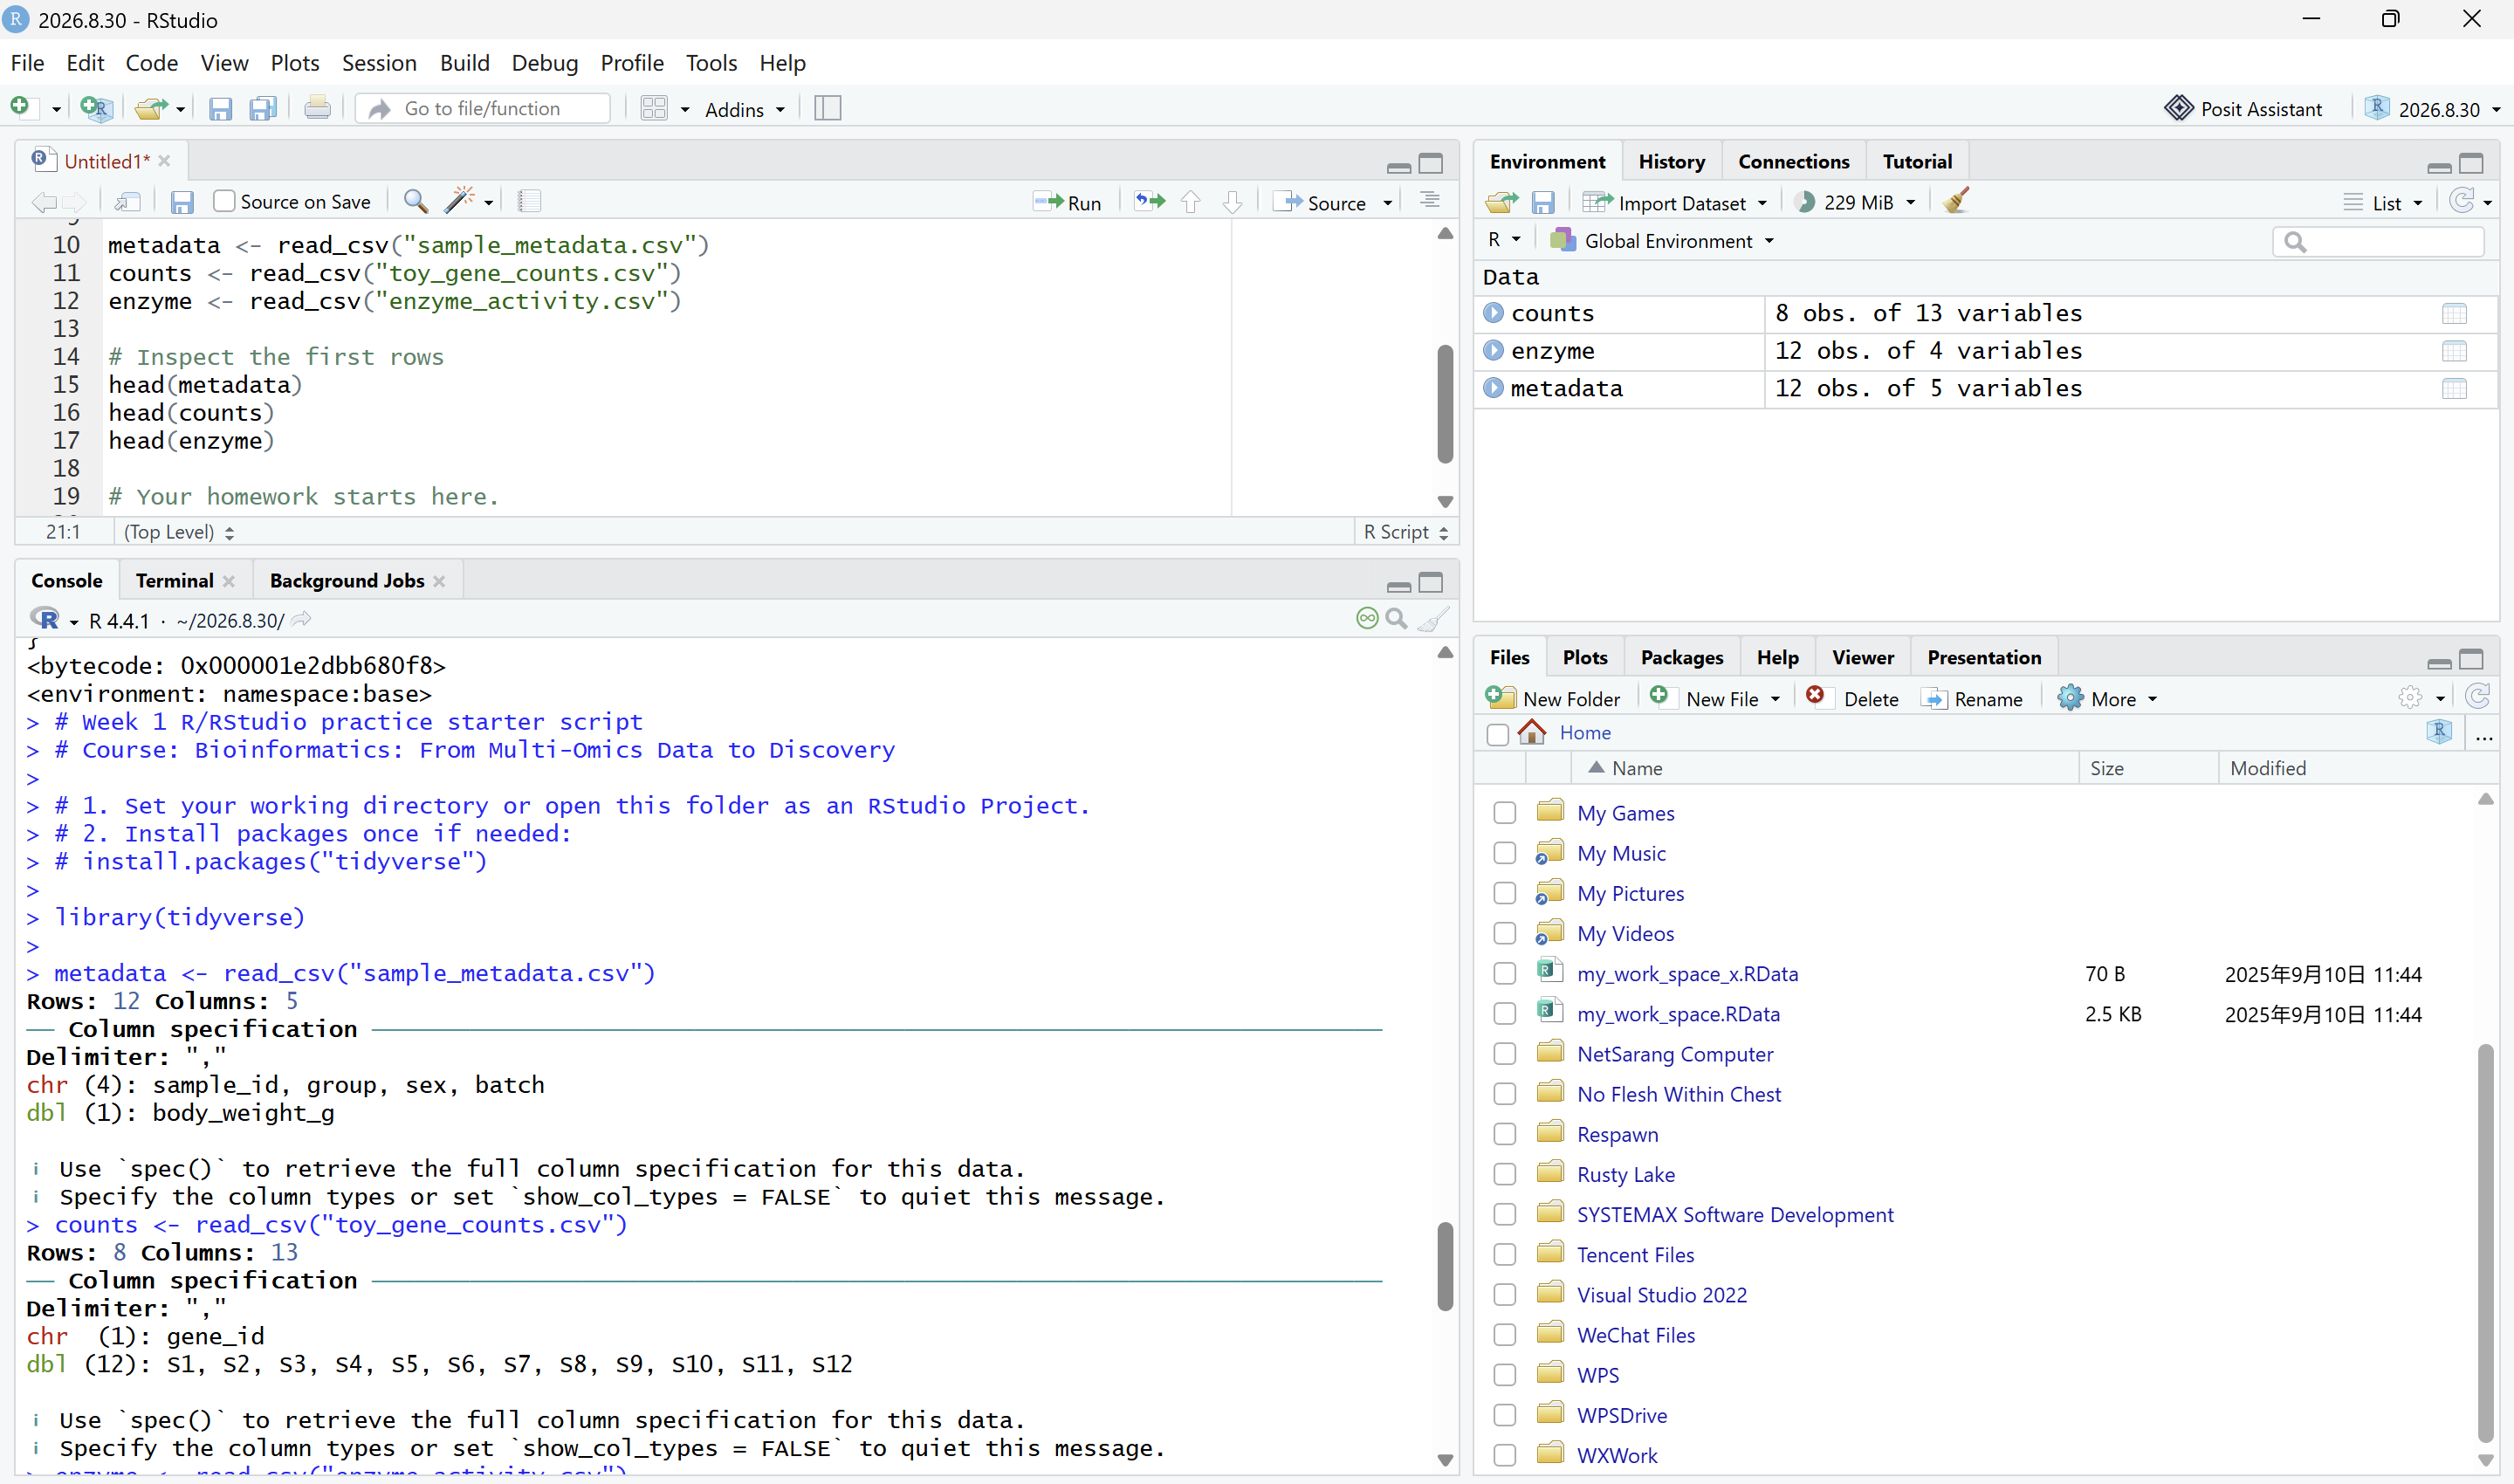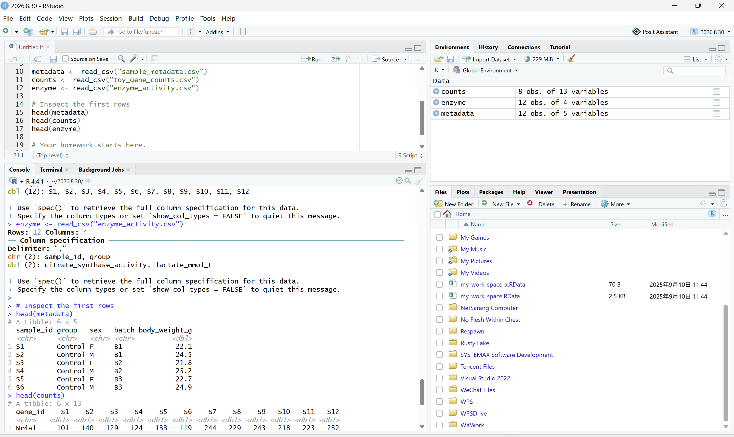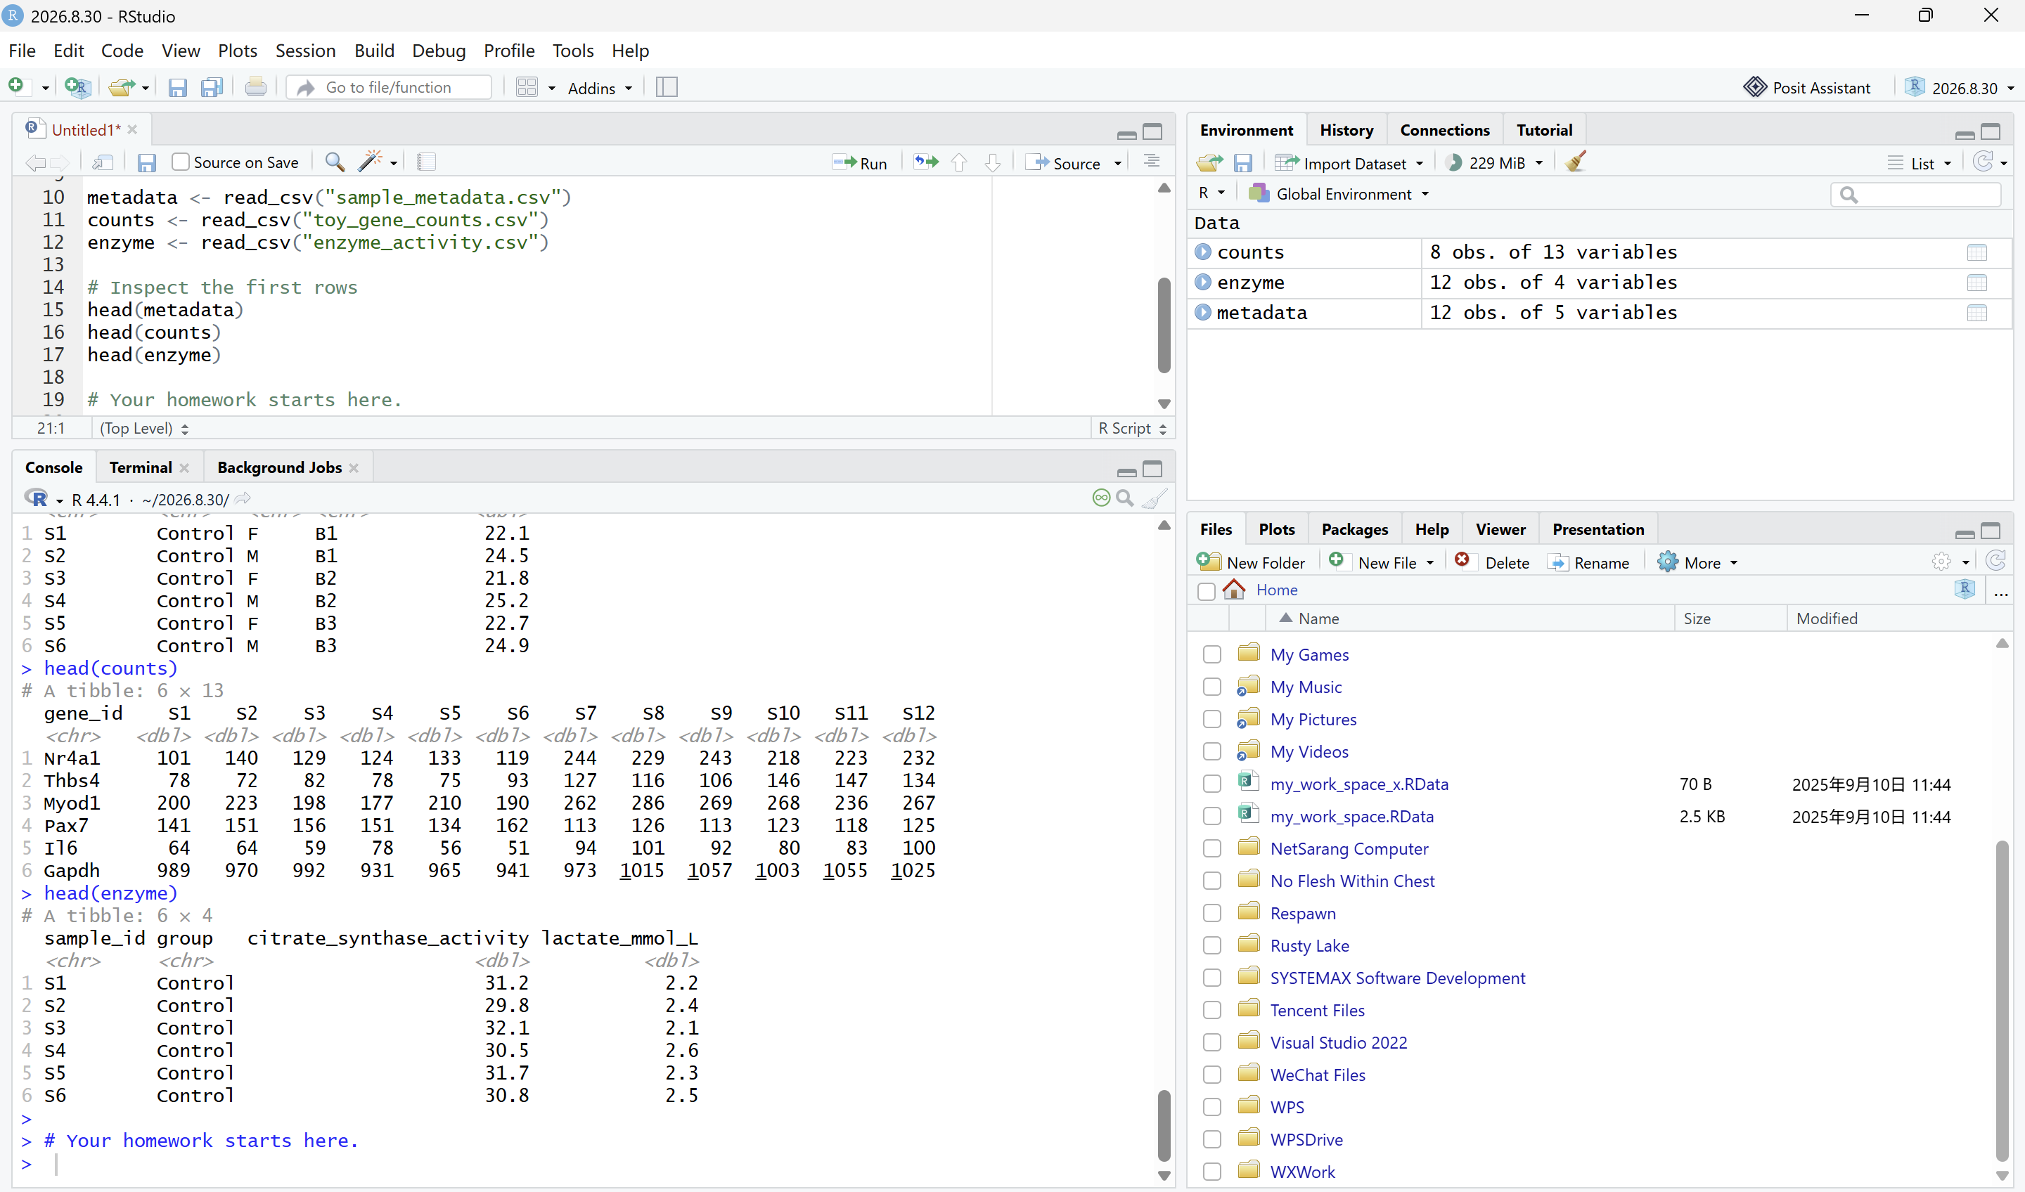
4. Install agent and create your first prompt log entry documenting AI use and verification.
4.1 Github:https://www.github.com/ (Create your account and repository for your homework submission). You need an account and a repository for homework submission (following the pattern: Bioinformatics_homework_Yourname_ID). You also need personal access token in together with repository link to activate your EasyMultiProfiler-web account.
4.2 Hermes-agent: https://github.com/NousResearch/hermes-agent (Install agent for coding) and Hermes WebUI (https://github.com/nesquena/hermes-webui)
4.3 Codex: https://chatgpt.com/codex/ (Install for coding and agent)
4.4 Deepseek API: https://platform.deepseek.com/usage (Top up ¥10 for agent set and switching to LLM accessed only on SUAT campus) or NVIDIA API

5. Install EasyMultiProfiler and EasyMultiProfiler-Web for multi-omics data analysis and homework submission (You can use Hermes or Hermes WebUI to complete the installation step)
EasyMultiProfiler: https://github.com/liubingdong/EasyMultiProfiler
EasyMultiProfiler-Web: https://github.com/xielab2017/EasyMultiProfiler-Web

